**Roxbury man gets life in prison for Grove Hall**

**killing five years ago**

February 13, 2015, 8:01 p.m.

A 24-year-old Roxbury man was sentenced on Friday to life in prison without the possibility of parole for gunning down an 18-year-old in Grove Hall five years ago and threatening a person who had information on the case, prosecutors said.

Darius Gibson was convicted last week of first-degree murder, unlawful possession of a firearm, and witness intimidation, according to a statement from the office of Suffolk District Attorney Daniel F. Conley.

Judge Linda Giles imposed the life sentence for the killing of Terrence Kelley and an additional sentence of five to seven years on the witness intimidation charge, the statement said. That sentence would only begin after Gibson completes another sentence on an unrelated triple shooing in Brockton.

Advertisement

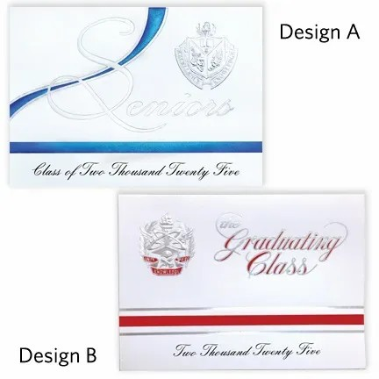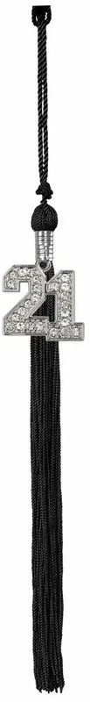

Cap, Gown, & T…

Memory Ice Tassel

Graduation Ann…

Graduation Announcements

Graduation Ann…

At the sentencing in Suffolk Superior Court, Kelley’s mother recounted her son’s life from his birth to his death, in a statement to the court.

“On April 26, 1992, my son was placed in my arms for the first time,” she said to the courtroom, according to the statement. “He was so precious, his face so flawless, his skin so soft, and I whispered ‘I love you’ for the first time.

**Get Today's Headlines in your inbox** Enter Email

[example@email.com](mailto:example@email.com)

**Sign Up**

The day's top stories delivered every morning.

“On May 28, 2010, I was led to a cold table where my beautiful son lay. This time his skin was not soft

-- only cold, very cold. And I whispered ‘I love you’ for the last time.”

During Gibson’s three-week trial, evidence showed that a witness lied to Boston police about the homicide and that Gibson threatened another witness, his former girlfriend, in an attempt to scare her into silence, prosecutors said.

On May 28, 2010, Gibson saw Kelley on Creston Street. Believing Kelley had robbed one of his acquaintances, Gibson chased him down the street and shot him six times as he fled, the district attorney’s office said.

James Austin, a friend of Gibson who witnessed the shooting, is serving a six- to eight-year sentence for being an accessory after the fact to Kelley’s murder, according to Conley’s office. He pleaded guilty last year.

Advertisement

[Melissa Hanson can be reached at melissa.hanson@globe.com or on Twitter @Melissa](mailto:MelissaHansoncanbereachedatmelissa.hanson@globe.comoronTwitter@Melissa) Hanson.

# BOSTON GLOBE VIDEO

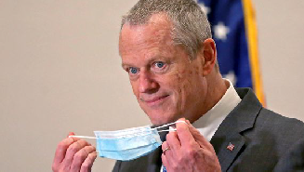

2:23

Baker announces ‘VaxMillions’ lottery program SHARE

Governor Charlie Baker announced residents who are fully vaccinated against COVID-19 will have the chance to win $1 million in a special Lottery sweepstakes. (Photo by Matt Stone/Boston Herald via AP)

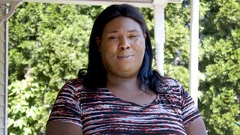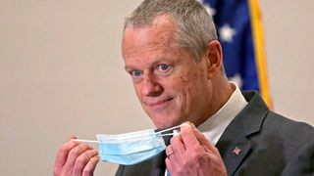

**Baker announces ‘VaxMillions’ lottery program**

**NOW PLAYING**

**Moose spotted on Route 3 in Chelmsford**

**What Black liberation means to me: Athena Vaughn**

SEE MORE VIDEOS

**MOST POPULAR ON BOSTONGLOBE.COM**

1. Life sciences is poised to be Boston’s dominant industry. Has the area become the Silicon Valley of biotech?
2. Some lawmakers want to ban critical race theory in schools. So, what is it?
3. How Massachusetts communities are celebrating the state’s first official Juneteenth
4. Is there something wrong with the air in South Portland, Maine?
5. Message in a bottle, tossed into the sea in Rhode Island, found in Azores
6. ‘My Name Is Bulger’: Two brothers, one documentary, an only-in-Boston story
7. Coolidge Corner Theatre gets go-ahead for major expansion
8. A power play? Steam plant owner aims to decarbonize downtown with huge building project
9. Baker announces ‘VaxMillions’ lottery program, offering $1 million cash prizes to boost vaccination rates
10. UMass Lowell to remain closed Wednesday while investigating ‘cybersecurity incident’



**VIEWS FROM OUR COLUMNISTS**

**YVONNE ABRAHAM**

Energy efficiency is a low-hanging fruit to combat climate change. So why can’t everyone get access to it?

**KEVIN CULLEN**

Bill Bratton on American policing and the challenge facing the Boston Police Department

**THOMAS FARRAGHER**

A salute across the ages to an old squad leader

**SHIRLEY LEUNG**

A working mother’s manifesto: Pandemic provides a once-in-a-generation chance to course correct how we work

**JENEÉ OSTERHELDT**

The pride I carry with me: Karim

**ADRIAN WALKER**

‘The best Boston movie no one’s ever seen’: ‘Blue Hill Avenue’ at 20

**MORE ON GLOBE.COM**

# PROVIDED BY: PHILIP MORRIS INTERNATIONAL

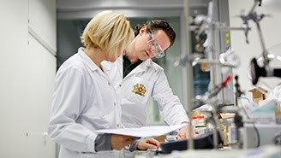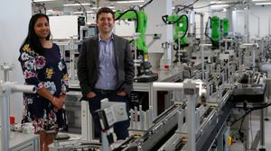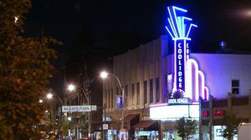

## Is a future without cigarettes within reach?

This company has a team of more than 400 scientists and R&D experts working on smoke-free alternatives.

# INNOVATION ECONOMY

## Life sciences is poised to be Boston’s dominant industry. Has the area become the Silicon Valley of biotech?

Since December, you can find six major indications that Boston is the undisputed center of the life sciences industry, a place where ideas and products that change — and save — people’s lives around the world originate.

# THE GREAT DIVIDE

## Some lawmakers want to ban critical race theory in schools. So, what is it?

As national debate over race-related curriculums rages on, here is a lesson on the subject and the controversy surrounding it.

## How Massachusetts communities are celebrating the state’s first official Juneteenth

For more than a century, Juneteenth was a Texan holiday, then a Southern holiday, commemorating the anniversary of June 19, 1865, when General Gordon Granger of the Union Army told formerly enslaved people in Galveston they were free. Now it will be celebrated for the first time across the Commonwealth as an official state holiday.

# GLOBE MAGAZINE

## Is there something wrong with the air in South Portland, Maine?

Residents have lived near more than 100 massive petroleum storage tanks for decades, never really knowing if they’re breathing in dangerous chemicals. Now they’re fighting to find out.

## Coolidge Corner Theatre gets go-ahead for major expansion

Brookline officials are reviewing a proposed expansion of the landmark Art Deco cinema that will add two new screens — and over 200 seats — as well as a larger lobby and third-floor community space, with a catering kitchen and outdoor roof deck.

# RI NEWS

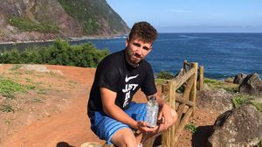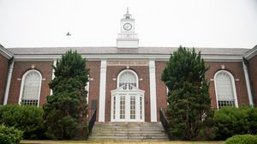

## Message in a bottle, tossed into the sea in Rhode Island, found in Azores

The note was written in 2018 by a 13- year-old who was visiting family in Rhode Island.

## UMass Lowell to remain closed Wednesday while investigating ‘cybersecurity incident’

The University of Massachusetts Lowell was forced to cancel all in- person and remote classes Tuesday and Wednesday “due to an IT outage,” the university said.

## Too hot? Sky-high prices may be scaring some buyers away from the housing market

A real estate trade group said Wednesday that there are some signs that the blistering seller’s market may be softening modestly after months of rising values.

## Baker announces ‘VaxMillions’ lottery program, offering $1 million cash prizes to boost vaccination rates

State officials on Tuesday said residents who are fully vaccinated against COVID-19 will have the chance to win $1 million in a special Lottery sweepstakes.

**MOST READ IN THIS SECTION**

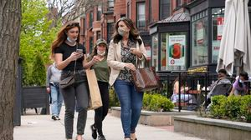

**THE GREAT DIVIDE**

**Some lawmakers want to ban critical race theory in schools. So, what is it?**

**How Massachusetts**

**communities are celebrating the state’s first official Juneteenth**

**Baker announces**

**‘VaxMillions’ lottery program, offering $1 million cash prizes to boost vaccination rates**

**GLOBE MAGAZINE**

**Is there something wrong with the air in South Portland, Maine?**

**The downside of ditching**

**masks: the return of colds, flu**

**UMass Lowell to remain**

**closed Wednesday while investigating ‘cybersecurity incident’**

**RI NEWS**

**Message in a bottle, tossed into the sea in Rhode Island, found in Azores**

**A Milton gay couple was**

**harassed anonymously for years. Then a piece of handwriting unraveled the mystery**

# FOLLOW US

**SUBSCRIBE NOW MY ACCOUNT CONTACT MORE**

Digital Access / Home Delivery / Gift Subscriptions

Log In /

Manage My Account / Customer Service

Help & FAQs / Globe Newsroom / Advertise

Newsletters / View The EPaper /

Order Back Issues / News In Education / Search The Archives / Privacy Policy / Terms Of Service / Terms Of Purchase / Work At Boston Globe Media /

Do Not Sell My Personal Information



**Your audience can listen, learn, and**

**dive deeper with Giide.**

Giide

**Learn more**

**METRO SPORTS BUSINESS & TECH OPINION**

WELCOME, JOHN

**TODAY'S PAPER**

**Summer Fitness Challenge Starts Monday**

Sign up now

©2021 Boston Globe Media Partners, LLC